I. What are chordates?
A. Four characters exhibited by all chordates(Figure 34.3):
1. Notochord – longitudinal flexible rod of fluid filled cells; located between
digestive tract and nerve cord. Provides skeletal support in higher vertebrates.
2. Dorsal Hollow nerve chord - Develops into CNS. Ventrally located in other
animals (e.g. arthropods).
3. Pharyngeal slits – Allow water to pass through mouth without entering
digestive tract. involved in filter feeding and respiration (as gills)
4. Muscular post-anal tail – propulsion
B. All chordates exhibit all 4 characters at some point during development, but may not
be present in the adult stage.
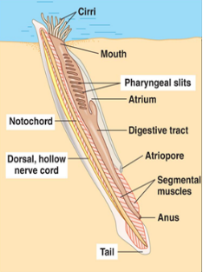

II. Major Phylogenetic lineages (A-H)
A. Lancelets
1.exhibit all four characters as an adult
2. Fish-like (but not a fish)
3. Pharyngeal slits used in filter feeding; cirri aid in this
a. Produce mucus to trap suspended particles
4. No respiratory system; gas exchange though skin
5. Closed circulatory system: no heart / hemoglobin; rarely
blood cells
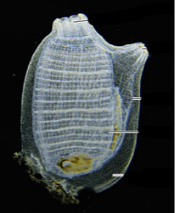
B. Tunicates
1. Mobile larvae morphologically similar to lancelet
2. During adult metamorphosis, tunicates lose 3 of 4 chordate
characters and become sessile
3. Adult stage is sessile filter feeder (using mucus to trap food)
4. Circulatory system with hear; pharyngeal slits perform some gas
exchange

Sub-group – Craniates (chordates with heads)
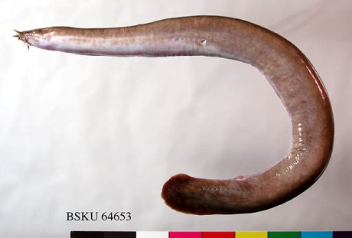
C. Hagfish
1. Cartilaginous skull
2. lack jaws and vertebrae
3. produce slime as an anti-predator defense

Sub-group – Vertebrates (chordates with vertebrae)
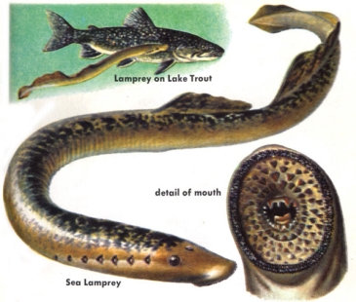
D. Lampreys - cartilaginous vertebral column (not calcified)
1. lack jaws
2. Feeding
a. Juveniles – filter feed using mucus (like lancelets)
b. adults – most don’t feed; some parasitic, suck blood

Sub-group – Gnathostomes (jawed vertebrates); Evolution of jaws
(from skeletal rods supporting gill slits; paired fins).Also evolve paired fins
and acquired immunity (i.e. immunological memory)
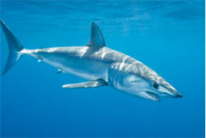

E. Condrichthyes - Sharks and rays –
1. cartilaginous skeleton w/ some bones.
2. Dorso-ventrally flattened

F. Osteichthyans (bony fish) Evolution of bony Endoskeleton. Two Groups.
1. Ray-fin fish
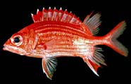
a. rudimentary lungs
b. swim bladder.
c. Laterally flattened
d. Most diverse of fish

2. Lobe-fin fish - Evolution of fins with rod-shaped bones supporting muscle
a. Coelacanth - thought extinct for 75 my

b. Lung fish - have gills; survival terrestrial desiccation via estivating in
mud in mucus cocoon
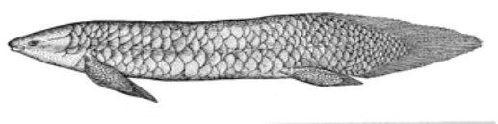

H. Tetrapoda - Evolution of legs from lobe-finned lung fish
1. Tiktaalik fossil
a. possess both tetrapod and fish characteristics;
b. possess important intermediates
1. Fins with wrists
2. Head disconnected from shoulder (neck)
3. Expanded ribs
4. flat head
c. likely lived in shallow waters

Important evolutionary adaptations in the chordates (see figure 34.2)
- Evolution of 4 chordates characters (notochord, nerve chord, slits, tail)
- Head
- Vertebral column
- Jaws, mineralized skeleton, paired fins
- Lungs / lung derivatives
- Lobed fins
- Legs
- Amniotic egg
- milk

